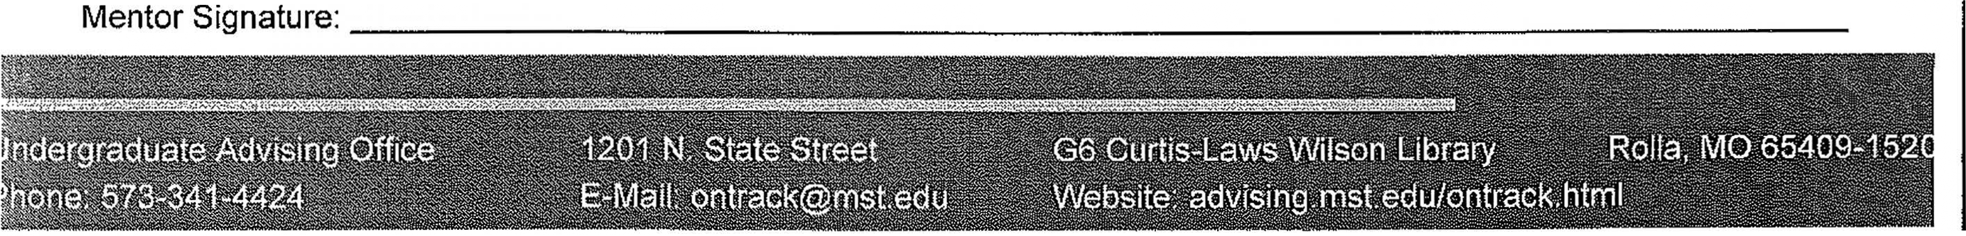

S&T Advising Center
On-Track Participant Agreement Term: The On-Track Program was created to help students get motivated, learn self-management, and study skills, and set goals to improve their academic and personal success. On-Track was designed to build on itself throughout the course of the semester; therefore, it will be most effective for those who participate fully throughout the entire program. To create the best possible experience for all involved, the mentors have developed the agreement below. On-Track participants must be made aware of the following expectations and agree to the following conduct and program requirements.
Please initial each of the following. By doing so, it is understood that you and your mentor will hold each other accountable for the items below:
I will dedicate 12-15 hours of this semester to On-Track towards the goal of making myself an excellent student, and I understand that the On-Track program will use my time constructively.
I understand that if I communicate openly and honestly with my mentor they will be better able to assist me in actively pursuing solutions to overcome my academic struggles.
I understand that any issues communicated to my On-Track mentor will be held in strict confidence among the S&T Advising Center staff except in situations involving threats of bodily harm, which must be reported to the S&T Critical Incidences Task Force.
I understand that for the duration of the On-Track program I will check my university provided email address approximately once per day and respond to communications from my mentor or the program within 24 hours.
I will provide at least a 24-hour notice for meeting cancellation or rescheduling with my mentor.
I understand that if I wish to be excused from a seminar absence, I must provide advance notice and a reason approved by my On-Track Mentor.
I will actively contribute to discussions and hands-on activities in seminars and group meetings.
I will be respectful of my group members' ideas and actions.
I understand that consistent disrespectful behavior towards my mentor or a peer will result in immediate dismissal.
I understand that my attendance is required at 7 seminars, 3 one-on-ones, and 3 group-on-ones. I will also complete up to 3 hours of prescribed activities agreed upon with my mentor, and fill out the final evaluation.
I understand that absences in excess of 1 seminar, the first 2 excused or 1 unexcused one-on-one or small group meeting, or 1 scheduled prescribed activity will result in being removed from the program.
I understand that 3 unresponsive attempts to communicate with me may result in my removal from the program.
I understand that failure to complete the final evaluation will result in my participation in the program being considered incomplete.

If upon evaluation by the participant's mentor and a staff member from the S&T Advising Center, the participant is not seen to be meeting these expectations, they may be removed from the program.
Participant Signature: Participant Name: Date:
S&T Advising Center 400 W. 14th Street G6 Curtis Laws Wilson Library Rolla MO, 65409

Phone: 573-341-4424 E-mail: ontrack@mst.edu Website: advising.mst.edu/ontrack.html

